**Project: Woodson Park Academy & YMCA-ELC**

**Week Ending: July 5th, 2019**

**THIS WEEK:**

* Demo crew has demobilized
* Site contractor’s survey crew onsite
* LDP approved 6/20/19
* CDCC has called in for pre-install meeting with COA – scheduled for 7/8
* COA watershed is installing new 8” water line off of Hollowell with no cost to this project.

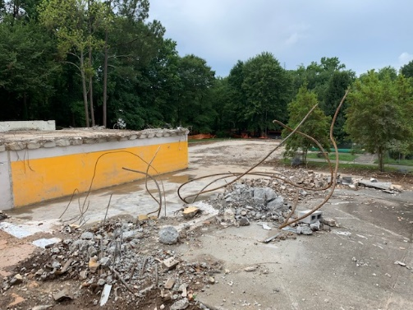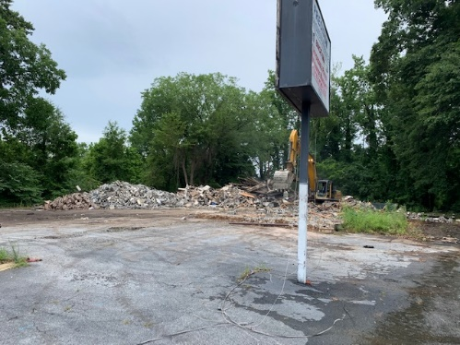

Transmission shop demo completed Demo of the vertical portion of the old school building complete

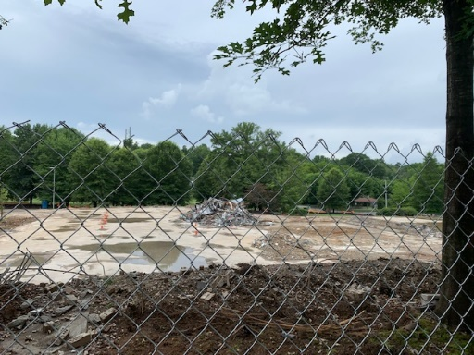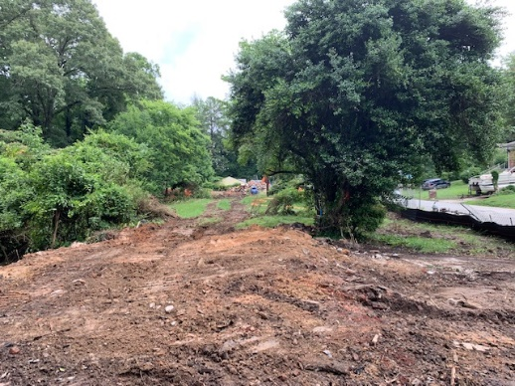

Demo continues on the existing All houses on Francis demoed

School building

**NEXT WEEK – July 8 thru July 12:**

* Erosion control per LDP plans
* Pre-install meeting with COA – 7/8
* Install web cam

**PAYMENT STATUS:**

* Gmp#1 $3,703,488.00
  + Paid to date amount $0.00
* GMP#2 $28,686,295.00
  + Paid to date amount $0.00

**SCHEDULED DATE OF SUBSTANTIAL COMPLETION**

* WPA – September 17, 2020
* YMCA-ELC - September 14, 2020

**PREPARED BY:**

* **Matt Dauber, Carroll Daniel Construction Co.**